MINISTRY OF PRAISE  St. Casimir Parish  August, 2019  Almighty God,  grant that with the help of St. Casimir’s intercession  we may serve you in holiness and justice. | 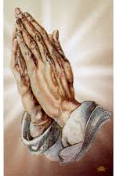

PLEASE PRAY FOR THE FOLLOWING INTENTIONS

- That families, through their life of prayer and love, become ever more clearly “schools of true human growth.” (Papal August intention)

- That through the intercession of Mary, Queen of Peace, every nation on earth will experience the justice and righteousness of the Gospel.

- That travelers by land, by sea, and by air will be kept safe and will arrive at their destinations in peace.

- That the Church will proclaim the truth of faith persuasively, courageously, and without compromise.

- That the members of this community may find ways to help build a world of greater respect for human life and human dignity.

- That God bless Father Bacevice and the Pastoral and Finance Councils in their efforts to secure the future of St. Casimir Parish.

- That all parishioners recognize their responsibility to St. Casimir Parish’s future through financial support, commitment to parish activities, sharing ideas, and most importantly prayer.

- That we accept the grace to remove from our lives all bitterness, anger, and malice.

- That those who suffer will experience the redemptive meaning of suffering through friendship with Jesus Christ.

- That those who pray be validated in their belief of its power.

WHAT’S HAPPENING AT ST. CASIMIR PARISH

August 2nd First Friday Adoration of the Blessed Sacrament, 8:00 - 9:00am in Church
August 14th Second Wednesday Holy Hour, 6:00-7:00pm in Church
August 15th Feast of the Assumption—Holy Day

SAINTS FOR AUGUST  SAINTS PONTIAN and HIPPOLYTUS  Pope and Martyr; Priest and Martyr  (d. 235)  August 13th | 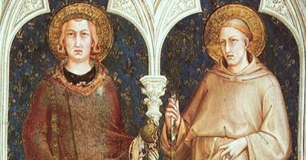

How blessed is this Church of ours, so honored and illuminated by God and ennobled in these our days by the glorious blood of martyrs.
(a thought about martyrdom by St. Cyprian, a bishop and martyr, d. 258)

During the Roman persecution of the early Church, some Christians were killed and others were sentenced to forced labor in metal or salt mines. No one came out alive. Hippolytus and Pontian were among those sentenced to the mines.
Hippolytus was the most important writer in the Church at the time. But he was also very critical and wanted the Church to be very strict with sinners. When Pope Callistus chose to be forgiving, as Jesus was, Hippolytus became very upset. He gathered followers around himself and became antipope. In 230 Pontian became pope, and Hippolytus continued to hold to his position. Pontian failed to persuade him otherwise. Hippolytus caused much unrest and confusion among Christian communities.
In 235 under the persecution of Maximus, Pontian was sentenced to the mines of Sardinia. He resigned as pope so that someone else could lead the Church. That same year Hippolytus was arrested and condemned to the same mines. In that dark, damp prison, the forgiving love of Christ finally penetrated Hippolytus’ heart and he was reconciled to Pontian. The two of them died in those mines, united in the love of God. They are martyrs for Christ and recognized as saints in the Church.

Sources: SAINT OF THE DAY, Leonard Foley, O.F.M., Editor; SAINTS AND FEAST DAYS, Christ Our Life Series, Loyola Press;
IN HIS LIKENESS by Rev. Charles E. Yost, SCJ, STL

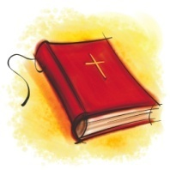
THOUGHTS FROM THE CATECHISM OF THE CATHOLIC CHURCH
To Bear Witness to the Truth

#2473 Martyrdom is the supreme witness given to the truth of the faith: it means bearing witness even unto death. The martyr bears witness to Christ who died and rose, to whom he is united by charity. He bears witness to the truth of the faith and of Christian doctrine. He endures death through an act of fortitude. “Let me become the food of the beasts, through whom it will be given me to reach God.”

REFLECTION

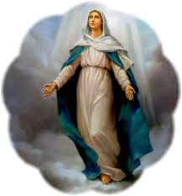

MARY’S ASSUMPTION IN HEAVEN
Father James M. Sullivan, O.P.

With the Solemnity of the Immaculate Conception we recall Mary’s being conceived without Original Sin. In this month of August, with the celebration of the Solemnity of the Assumption, we keep the great feast of Mary’s being taken into heaven, body and soul. And this is not to be thought of so much as an ending, as it is a new beginning.

As Pope Francis reminded us in proclaiming the Year of Mercy in “Misericordiae Vultus” on April 11, 2015: “No one has penetrated the profound mystery of the Incarnation like Mary. Her entire life was patterned after the presence of mercy made flesh. The Mother of the crucified and risen one has entered the sanctuary of divine mercy because she participated intimately in the mystery of his love.” The Assumption is that entering the sanctuary of divine mercy.

One of the corporal works of mercy that is easily forgotten in our society is that of burying the dead. The dead are buried, yes, but how many people go to the wake, or to the funeral, or even to the graveside? This corporal work of mercy reminds us all not only of our own mortal body but even more so of our own immortal soul. The Blessed Virgin Mary, assumed into heaven, body and soul, calls us to herself and to the fullness of mercy.
Source: MAGNIFICAT, Vol. 18, No. 6, August 2016, p. 19

