MINISTRY OF PRAISE

St. Casimir Parish
June, 2019

Almighty God,
grant that with the help of St. Casimir’s intercession
we may serve you in holiness and justice.

PLEASE PRAY FOR THE FOLLOWING INTENTIONS

- That priests, through the modesty and humility of their lives, commit themselves actively
to a solidarity with those who are most poor. (Papal June intention)

- That our relationships will be deepened and made holy through the Holy Spirit, the bond of love
in the Blessed Trinity.

- That blessings come to all fathers on Father’s Day.

- That our parish’s communion in faith will become a more perfect likeness of the Blessed Trinity.

- That the real presence of Jesus will be experienced in all marriages, all business relationships,
all daily encounters, and in our friendships.

- That God bless Father Bacevice and the Pastoral and Finance Councils in their efforts to secure the future
of St. Casimir Parish.

- That all parishioners recognize their responsibility to St. Casimir Parish’s future through financial support,
commitment to parish activities, sharing ideas, and most importantly prayer.

- That those who govern nations will protect human rights, further the work of justice, and advance
the freedom of those in their charge.

- That the supernatural peace of the Spirit will bring new life and confidence to the alienated,
the doubt-ridden, and those on the verge of despair.

- That those who pray be validated in their belief of its power.

WHAT’S HAPPENING AT ST. CASIMIR PARISH

June 7th First Friday Adoration of the Blessed Sacrament, 8:00 - 9:00am in Church
June 9th Baltic Commemoration, 2:00pm in Church
June 12th Eucharistic Adoration, 6:00 - 7:00pm in Church

SAINT FOR JUNE  SAINT PAULINUS OF NOLA  Bishop  (354?-431)  June 22nd | 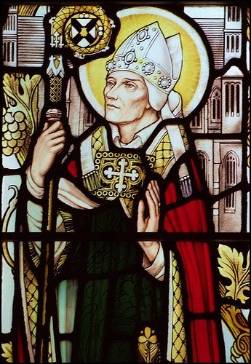

Sell your belongings and give alms. Provide money bags for yourselves that do not wear out, an inexhaustible treasure in heaven that no thief can reach nor moth destroy. For where your treasure is, there also will your heart be. (Luke 12: 33-34)
This is the Scripture passage that Paulinus and his wife followed after their retirement and the death of their son.

Born in Bordeaux, France, Paulinus was the son of the Roman prefect of Gaul, who had much property in Gaul and Italy. Paulinus became a distinguished lawyer and held several public offices in the Empire. He was a correspondent and friend of St. Augustine, St. Jerome, St. Martin, St. Gregory and St. Ambrose.
Paulinus and his Spanish wife, Theresia, retired at an early age and planned to live a life of leisure. Shortly after their retirement they were baptized. Later they had a son, Celsus, who died after only eight days. Paulinus and Theresia decided to give their wealth to the poor, as Jesus had said, and to live a very simple life.
Ordained a priest with the consent of Theresia, Paulinus turned to a life of solitude and prayer in a monastic setting. His wife had similar interests but died after just a few years. Paulinus was chosen to be bishop of Nola, and he guided the Church there for approximately 21 years. His ministry in Nola took place during the difficult time of the Visigoth invasions, when much in northern Italy was destroyed. Paulinus was known as a pillar of strength for his people. He died in 431.

Sources: IN HIS LIKENESS, Rev. Charles E. Yost; CHRIST OUR LIFE SERIES, Loyola Press; SAINT OF THE DAY, Leonard Foley

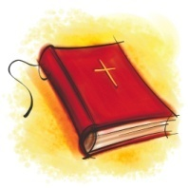
THOUGHTS FROM THE CATECHISM OF THE CATHOLIC CHURCH
The Visible World

#341 The beauty of the universe: The order and harmony of the created world results from the diversity of beings and from the relationships which exist among them. Man discovers them progressively as the laws of nature. They call forth the admiration of scholars. The beauty of creation reflects the infinite beauty of the Creator and ought to inspire the respect and submission of man’s intellect and will.

#346 In creation God laid a foundation and established laws that remain firm, on which the believer can rely with confidence, for they are the sign and pledge of the unshakeable faithfulness of God’s covenant. For his part man must remain faithful to this foundation and respect the laws which the Creator has written into it.

REFLECTION

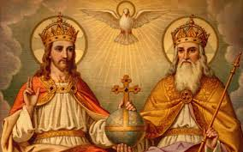

A CHRISTIAN PRAYER IN UNION WITH CREATION
(Given by Pope Francis on the Solemnity of Pentecost, May 24, 2015, at St. Peter’s Basilica in Rome)

Father, we praise you with all your creatures. They came forth from your all-powerful hand; they are yours, filled with your presence and your tender love. Praise be to you!

Son of God, Jesus, through you all things were made. You were formed in the womb of Mary our Mother, you became part of this earth, and you gazed upon this world with human eyes. Today you are alive in every creature in your risen glory. Praise be to you!

Holy Spirit, by your light you guide this world toward the Father’s love and accompany creation as it groans in travail. You also dwell in our hearts and you inspire us to do what is good. Praise be to you!

Triune Lord, wondrous community of infinite love, teach us to contemplate you in the beauty of the universe, for all things speak of you. Awaken our praise and thankfulness for every being that you have made. Give us the grace to feel profoundly joined to everything that is.

God of love, show us our place in this world as channels of your love for all the creatures of this earth, for not one of them is forgotten in your sight. Enlighten those who possess power and money that they may avoid the sin of indifference, that they may love the common good, advance the weak, and care for this world in which we live. The poor and the earth are crying out. O Lord, seize us with your power and light, help us to protect all life, to prepare for a better future, for the coming of your Kingdom of justice, peace, love and beauty. Praise be to you! Amen.

Source: ON CARE FOR OUR COMMON HOME, LAUDATO SI’, Pope Francis Encyclical Letter (2015), pp. 119-120

